suggested One hour of learning per day and 30 minutes of daily reading
grade 3 & 4 Work Package for Week of May 18th- May 22th
 |  | Monday, May 18th |  |  | Monday, May 18th
 |  | Literacy Calendar |  |  | numeracy calendar
 |  | Happy Victoria Day! Enjoy your family time. |  |  | Happy Victoria Day!
 |  | Tuesday, May 19th |  |  | Tuesday, May 19th
 |  | literacy calendar |  |  | numeracy calendar
 |  | Take a nature walk. If you wish, take some photos, bring home objects like leaves or stones. Upon your return home, jot down some notes or words about what you noticed, what you wonder, how it felt and what you heard. |  |  | Pick a number from 10-20. If you flipped a pair of coins that many times, predict how many times you would get the following results: 1- 2 heads, 2- 2 tails or 3 – 1 head and 1 tail. Test your prediction by flipping a pair of coins the number of times that you chose and record your results. Explain why your results were close to or different than what you predicted.
 |  | Read for 30 minutes.
 |  | Wednesday, May 20th |  |  | Wednesday, May 20th
 |  | Literacy calendar |  |  | numeracy calendar
 |  | Continuing with yesterday’s activity of the nature walk. Create a collection of sketches of items you gathered with labels and record your observations in sentences. Consider all your senses when recording. Use some interesting describing words. Read your writing to someone else and ask them if they can “make a picture in their mind’ about what you saw. |  |  | Find a partner and play Hop to 500! You choose a number between 1 and 10. Your partner may either add 10 or 100 to your starting number. Now you add either 10 or 100 to the number your partner said. Continue taking turns, adding either 10 or 100 each time. The player who gets closest to 500 without going over is the winner! Now play again with 1,000 as the target number!
 |  | Read for 30 minutes.
 |  | Thursday, May 21st |  |  | Thursday, May 21st
 |  | literacy calendar |  |  | numeracy calendar
 |  | Choose any book to read. Talk with another person about how it is the same or different to your own life. Make some connections to other books you have read or shows you have seen. How are they  the same or different? If you want, you can create a simple chart with the headings: Book, My Life, Other Stories and record some of your ideas. |  |  | 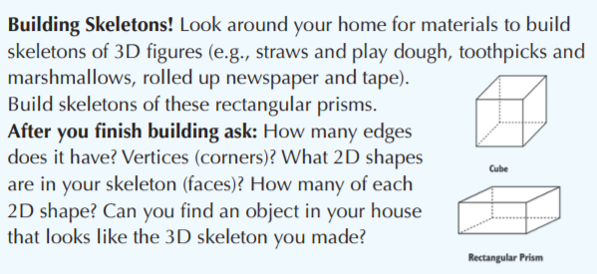
 |  | Read for 30 minutes
 |  | Friday, May 22nd |  |  | Friday, May 22nd
 |  | Literacy Calendar |  |  | numeracy calendar
 |  | Brainstorm some rhyming words. (e.g. cat-sat, bee-free) Write a silly poem (e.g. I glanced in the mirror  In my room last night,  And what I saw  Was a crazy sight......  Read it to someone else. See if they can find your rhyming words. |  |  | Pattern Hunt! Find a pattern in your home. Patterns can be found on dishes, fabrics, wallpaper and even flooring! Take a picture or make a sketch or describe your pattern. See if someone else can find it. Go to a safe outdoor space or look out your window and share the patterns you see.
 |  | Read for 30 minutes.

steam challenge & Music |  | out | Physical education
Music https://www.youtube.com/watch?v=0vrK1POQPiE Watch the video and play the games. Also environmental percussion activity below. https://www.learninggamesforkids.com/music_and_art_games/match-three-percussion-instruments.html |  |  | See below
LIFESKILLS CHALLENGE: Help prepare a meal with your family this week.
FRENCH EXTENSION: For French this week I'm attaching a picture, video, and song to review "Le Corps". We had just started it a few weeks before schools closed down. See also attachment Le Corps. 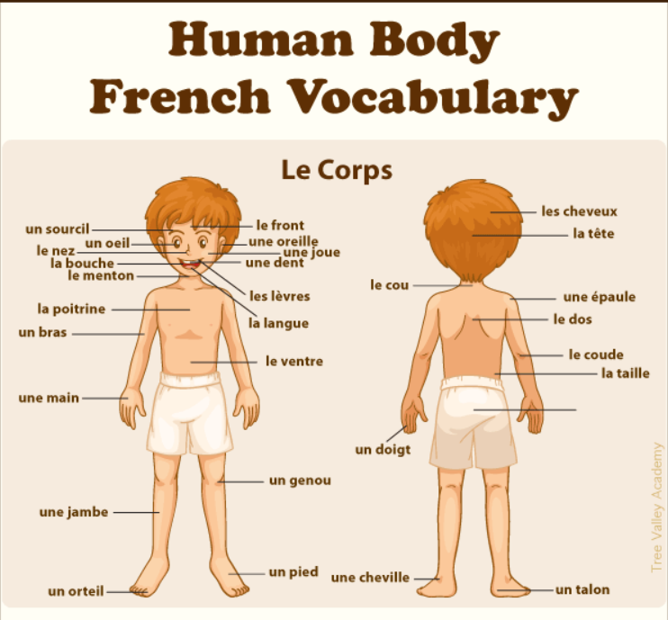
https://www.youtube.com/watch?v=fho0yuJ4Fag
https://www.youtube.com/watch?v=bChrAwLzoSo&amp=&feature=youtu.be
WEEBLY:
http://mrsduffsclassroom.weebly.com
http://mrswilsongrade45.weebly.com/
District Information:
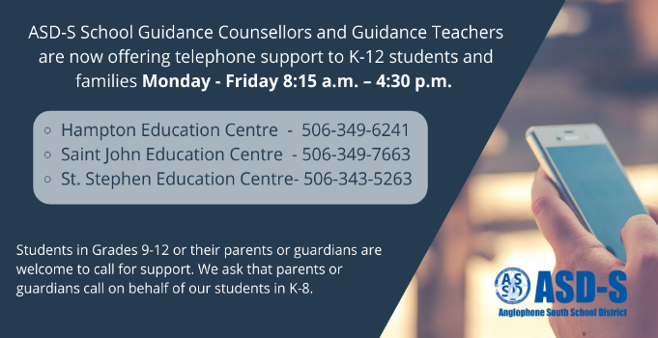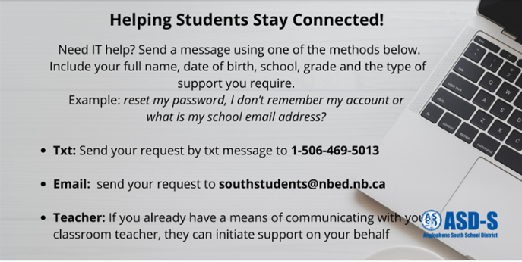
Self Regulation Strategies: Make a Stressball! This week challenge yourself to make a tool to help with emotions. Below are directions to make a stressball. What are some feelings you have that this tool would help to calm?
